Gases and their Properties

Select the alternative that correctly answers the following questions.

1. Which of the following statements is FALSE?

a) Carbon dioxide can be prepared by adding dilute hydrochloric acid to a carbonate or hydrogen carbonate.
b) Heating of a carbonate or hydrogen carbonate will produce carbon dioxide.
c) Carbon dioxide will react with both sodium hydroxide solution and concentrated nitric acid.
d) Dry ice is solid carbon dioxide and it sublimes at room temperature.

The next two questions refer to the diagram below which shows the apparatus used to prepare oxygen gas in the laboratory.
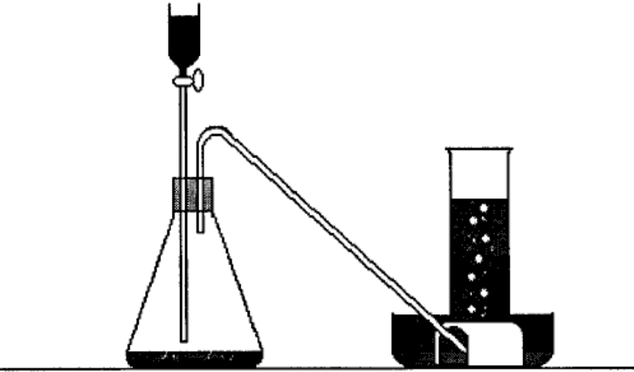

2. What is the name of the solution in the tap funnel which decomposes to produce the oxygen gas?

a) Sodium sulfate.
b) Potassium nitrate.
c) Hydrogen peroxide.
d) Sulfuric acid.
3. By what method is the oxygen gas collected as seen in the diagram above?

a) Upward displacement of water.
b) Downward displacement of water.
c) Upward displacement of air.
d) Downward displacement of air.

4. Limewater can be used to detect the presence of carbon dioxide gas. What substance is limewater, and what precipitate forms when carbon dioxide gas is passed through it?

a) Sodium hydroxide and sodium carbonate.
b) Sodium chloride and calcium carbonate.
c) Calcium chloride and calcium carbonate.
d) Calcium hydroxide and calcium carbonate.

5. A gas was produced in the laboratory which had the following properties:

1. A pale yellow colour.
2. A distinctive, pungent odour.
3. Reacted readily with most metals.
4. Turned moist litmus red, then white.

Which of the gases below has all of these properties?

a) Ammonia.
b) Oxygen.
c) Chlorine.
d) Sulphur dioxide.

6. Which ONE of the following is NOT a property of sulfur dioxide gas?

a) It is colourless.
b) It has a strong, acrid smell.
c) It is soluble in water forming sulphurous acid.
d) It can be collected in the laboratory by the downward displacement of air.

7. Which of the following substances is used to produce ammonia in the laboratory?

a) Ammonium chloride and calcium hydroxide.
b) Ammonium chloride and hydrochloric acid.
c) Calcium carbonate and nitric acid.
d) Copper and nitric acid.

8. Why is helium gas used in preference to hydrogen gas in balloons?

a) Helium gas is non-toxic.
b) The inert nature of Helium makes it much safer to use.
c) The smaller size of the hydrogen molecules allows them to escape too easily from balloons.
d) Helium is lighter than hydrogen.

9. The following statements describe some of the characteristics of a gas.

1. The gas is a component of air and exists as diatomic molecules.
2. The gas is colorless, tasteless and odorless.
3. This gas is non_toxic.
4. The gas does not react with water, acids or alkalis.
5. The gas can be used as one of the reactants in the production of ammonia.

The gas described is

a) hydrogen. c) chlorine.
b) oxygen. d) nitrogen.

10. Under suitable conditions, carbon monoxide and oxygen will react:
2CO(g) + O₂(g)  2CO₂(g)
Before reaction the volume of reacting gases was 1000 cm^{3 .} When the reaction had reached completion the volume had decreased to 800 cm³. Analysis showed that this mixture contained only carbon dioxide and oxygen.

If all gas volumes were measured at the same pressure and temperature, how much of each gas was present in the original mixture?

a) 400 cm³of CO (g) and 200 cm³of O₂(g).
b) 200 cm³ of CO(g) and 400 cm³ of O₂(g.
c) 200 cm³ of CO(g) and 800 cm³ of O₂(g).
d) 400 cm³ of CO and 600 cm³ of O₂(g) .
11. Which of the following statements is NOT consistent with the kinetic theory of gases?

a) Any two gases at the same temperature will have the same average kinetic energy
b) The molecules of a gas move in random, straight line motion, colliding with the walls of their container and each other
c) The average distance between gas molecules is large compared to the relatively small size of the molecules themselves.
d) There is some loss of energy as gas molecules collide because these collisions are not perfectly elastic.
e) When the molecules within a gas come into close contact there are no attractive or repulsive forces between them.

12. Which of the following will cause an increase in the average kinetic energy of a gas?

a) Increasing the pressure of the gas.
b) Decreasing the pressure of the gas.
c) Increasing the volume of the container housing the gas.
d) Increasing the temperature of the gas.
e) Adding more gas particles to the system.

The next two questions refer to the graph below, which shows the vapour pressure and temperature relationship for water and an unknown substance X.

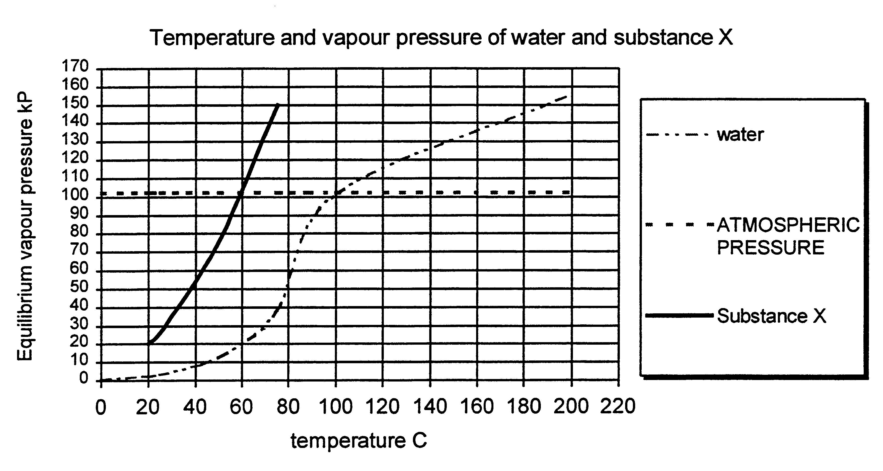

13. What is the normal boiling point of Substance X?

- 100ºC
- 150 ºC
- 40ºC
- 60 ºC

14. At normal atmospheric pressure ( approximately 101.3 kPa), the boiling point of water is 100 ºC. Use the graph to predict the boiling point of water on Mt. Everest where the atmospheric pressure would only be 35 kPa.

a) 75 ºC b) 100 ºC
c) 60 ºC d) 80 ºC

15. Consider equal volumes of hydrogen and oxygen gas at the same conditions of temperature and pressure. Which of the following statements is FALSE?

a) The molecules have the same average kinetic energy.
b) The molecules of hydrogen would have a greater average velocity than those of oxygen.
c) The molecules of hydrogen and oxygen would have the same average velocity.
d) Oxygen molecules have greater molecular mass than hydrogen molecules.
e) The kinetic energy of the gas molecules is a function of both the masses and velocities of the molecules.

16. Boyle’s Law states that:

a) The pressure exerted by a given mass of gas at constant volume is directly proportional to the absolute temperature of that gas.
b) The volume and absolute temperature of a gas are directly proportional.
c) The pressure exerted by a given mass of gas at constant temperature is inversely proportional to the volume occupied by the gas.
d) The pressure exerted by a given mass of gas at constant temperature is directly proportional to the volume of the gas.

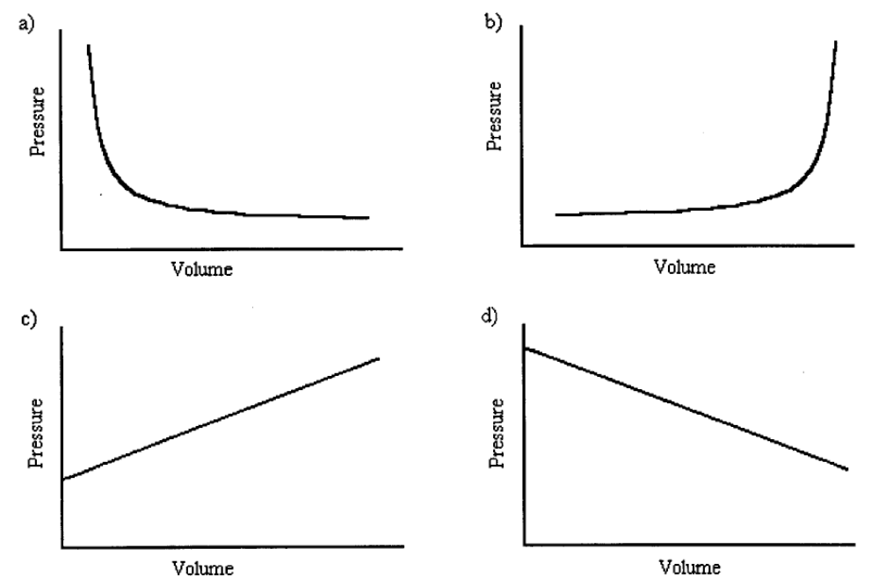17. Which of the graphs below shows the relationship between the pressure and volume of a gas at constant temperature?

18. Convert -30ºC to Kelvin.

a) 303 K b) 60 K
c) 243 K d) 130 K

19. A gas syringe contains 50 mL of oxygen at 30ºC. To what temperature must it be heated to cause the gas volume to double?

a) 60 ºC b) 333 ºC
c) 303 K d) 333 K

20. Calcium reacts with water as shown:

Ca(s) + 2H₂O(l) Ca(OH)₂(aq) + H₂(g)

What volume of hydrogen would be liberated at STP when 16 g of calcium reacts with excess water?

a) 16 L b) 22.4 L
c) 10.5 L d) 8.96 L

21. Which ONE of the following would NOT occur when the pressure of a given mass of gas at constant temperature is increased?

a) The number of collisions between the gas molecules and the walls of their container increases.
b) The average kinetic energy of the molecules increases.
c) The volume of the gas decreases.
d) The number of gas molecules remains the same.

22. A 500 mL sample of nitrogen gas is collected over water at 20ºC and 105 kPa. The vapour pressure of water at 20ºC is 2.34 kPa. What is the partial pressure of the nitrogen gas at 20ºC?

a) 497.66 kPa b) 102.66 kPa
c) 105 kPa d) 500 kPa

23. Which of the following is NOT true about Absolute Zero?

a) Absolute Zero is equal to 0ºC.
b) At Absolute Zero, an ideal gas would not occupy any space.
c) At Absolute Zero, the molecules of a gas have no kinetic energy.
d) Absolute Zero is equal to –273ºC.

24. The following diagram represents two bulbs containing gases connected by a valve.

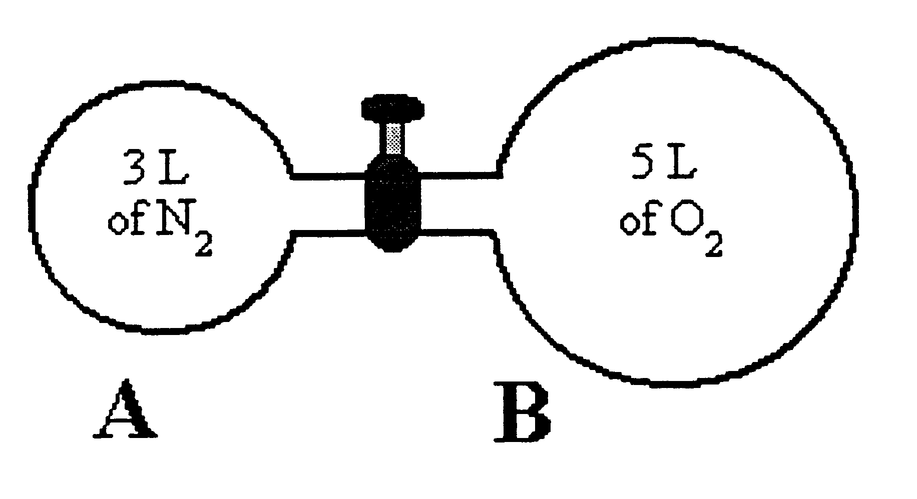

Bulb A has a volume of 3L and contains nitrogen gas at 200 mm pressure. Bulb B has a volume of 5 L and contains oxygen gas at 400 mm pressure. If the valve is open to allow mixing of the two gases, what would be the partial pressure of the oxygen in the mixture?
(Temperature remains constant)

a) 250 mm b) 200 mm
c) 300 mm d) 600 mm
25. If the carbon dioxide produced in the above reaction was collected and conditions set to STP, what volume would the carbon dioxide gas occupy?

a) 88.0 mL b) 100.0 mL
c) 22.4 mL d) 448 mL

The next two questions are based on the reaction that occurs when the hydrocarbon, propane C₃H₈, burns in oxygen to produced carbon dioxide and water vapour only.

C₃H₈(g) + 5O₂(g) 3CO₂(g) + 4H₂O(g)

26. If 100 mL of propene is burnt, what is the minimum volume of oxygen required for the complete combustion of the propene?

a) 100 mL b) 300 mL
c) 400 mL d) 500 mL

27. In the case of question 6 above, what volumes of gaseous products are formed?

a) 100 mL of CO₂ and 100 mL of H₂O.
b) 200 mL of CO₂ and 200 mL of H₂O..
c) 100 mL of CO₂ and 200 mL of H_{2.}O.
d) 300 mL of CO₂ and 400 mL of H₂O.

